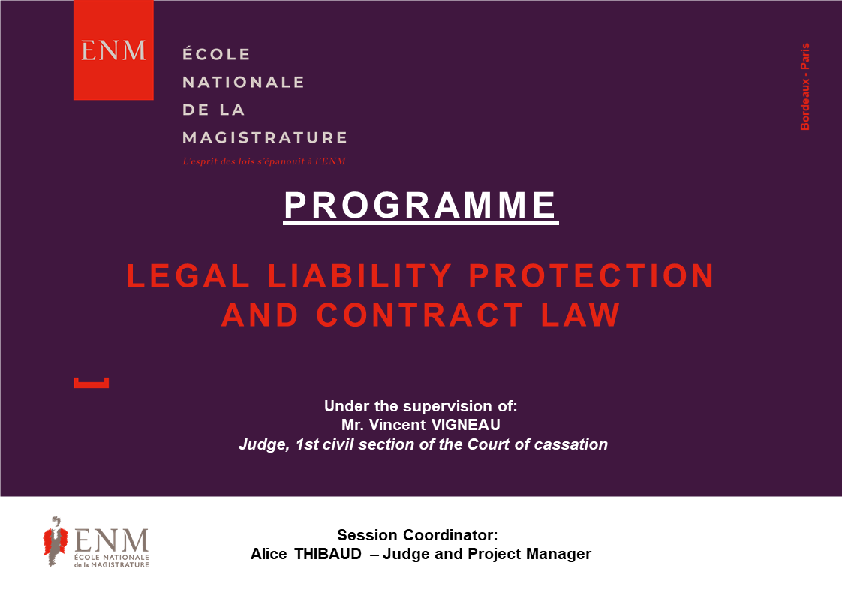

All times below are Paris time (Central European Time, CET).
The links to connect will be sent to your mail address soon.
Please connect 15 minutes before each session.

Contact :
Emilie BREYNE – Project Manager – International Department
emilie.breyne@justice.fr / (+33) 01 44 41 88 24

PROGRAMME

Monday 29 March 2021

- 08:45 a.m. – 09:00 a.m.

Welcome speech - Recommendations for the use of the tool

- 09:00 a.m. – 12:00 p.m.

The role of the judge in the contract since the reform from the regulation of 10 February 2016
Mr Vincent VIGNEAU, Judge, 1st civil section of the Court of cassation

Tuesday 30 March 2021

- 09:00 a.m. – 12:00 p.m.

Contractual techniques for securing contracts
Professor Bruno DONDERO and Professor Mathias LATINA

Wednesday 31 March 2021

- 10:00 a.m. – 12:00 p.m.

Application of the foreign law contractually stipulated by the French judge
Maître Alice MEIER-BOURDEAU, lawyer at the Conseil d'Etat and at the Cour de cassation
Thursday 1st April 2021

- 10:00 a.m. – 12:00 p.m.

Settlement of disputes through arbitration
Professor Maximin DE FONTMICHEL

Friday 2 April 2021

- 10:00 a.m. – 12:00 p.m.

The notarial deed
Mr Lionel GALLIEZ, notary in Paris, vice-president of the International Union of Notaries

