

In cooperation with
ETHNIKI SCHOLI DIKASTON LEITOURGON

Workshop on
Principles of EU Environmental Law

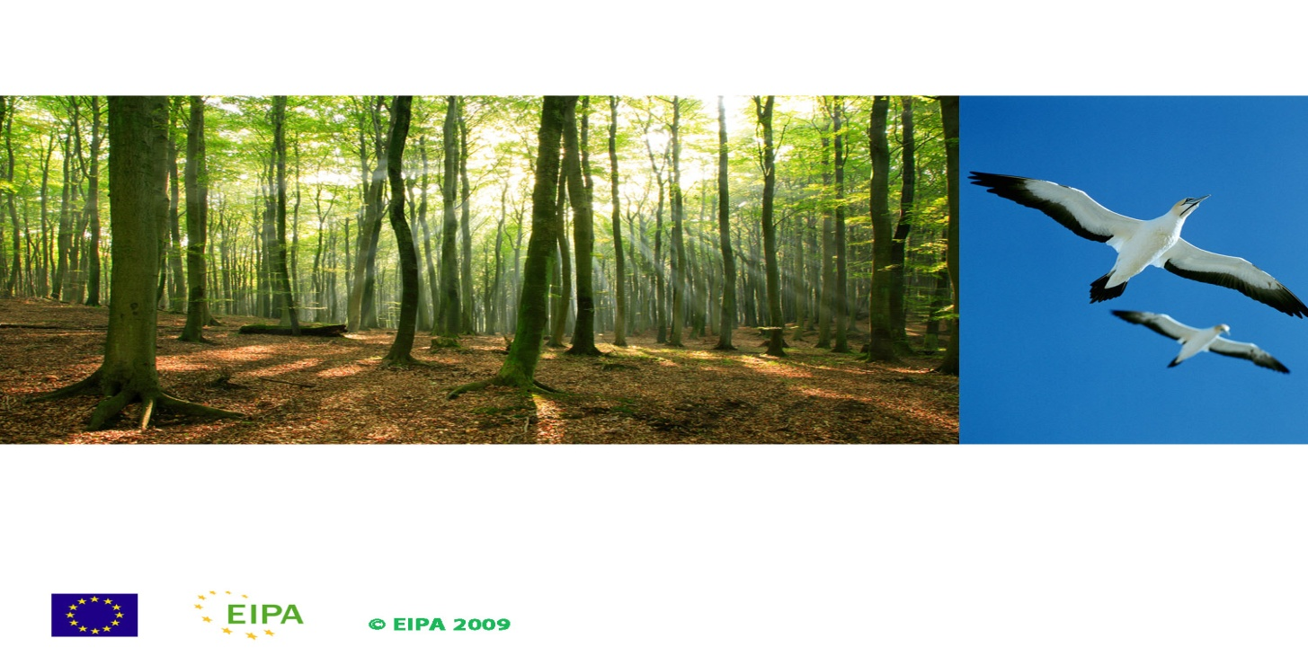

Thessaloniki, 12–14 March 2012

programme

Monday, 12 March 2012
9.00 – 9.45 Welcome and Introductory session
Welcome and introduce participants, introduce the facilitators, explain the program and main objectives of the event and give overview on interactive sessions of first day
Igor Dizdarevic (Lecturer, project leader, EIPA), Ralf Jülich (legal expert, activity leader, EIPA)
9.45 – 10.45 Role of the national judge in the implementation of EU law: Direct effect and Preliminary ruling
Introduction into the relevance of EU environmental law for national decisions, and ECJ case procedure initiated by national courts
Igor Dizdarevic
Coffee Break (10.45 – 11.00)
11.00 – 11.30 Introduction into the Polluter Pays Principle
History, function and manifestation of the Polluter Pays Principle in international and in EU environmental law
Gerhard Roller (Professor of Environmental Law, University of Applied Sciences, Bingen, Germany)
11.30 – 13.15 Case Study I - Polluter Pays Principle
Understanding and application of the Polluter Pays Principle in the field of waste management
Igor Dizdarevic and the participants, largely in parallel working groups
Lunch Break (13.15 – 14.15)
14.15 – 15.00 Application of the Polluter Pays Principle in (other) areas of EU environmental law
Presentation of legislation and ECJ jurisprudence related to the Polluter Pays Principle
Ralf Jülich
15.00 – 16.00 Environmental Liability Directive 2004/35/EC
Presentation of the history, objective and key elements of the Directive 2004/35/EC on environmental liability with regard to the prevention and remedying of environmental damage
Hans Lopatta (EU Commission, Directorate-General for the Environment)
Coffee Break (16.00 – 16.15)
16.15 – 17.00 Introduction into the Preventive and the Precautionary Principles
History, function and manifestation of the Preventive and the Precautionary Principles in international and in EU environmental law
Gerhard Roller

Tuesday, 13 March 2012
9.00 – 10.30 Case Study II – Precautionary Principle
Understanding and application of the implications of the Precautionary Principle and the Safeguard Clause in the field of genetically modified organisms
Gerhard Roller and the participants, largely in parallel working groups

Coffee Break (10.30 – 10.45)
10.45 – 11.15 Case Study II continuation
Continuation – presentation of working group results and debriefing
Gerhard Roller and the participants
11.15 – 11.45 Further principles of EU environmental law
Presentation of history, function and manifestation of further principles of EU environmental law
Igor Dizdarevic

11.45 – 13.15 Case Study III – Precautionary Principle
Understanding and application of the implications of the Precautionary Principle and the Proportionality Principle in the field of nature protection
Ralf Jülich and the participants, largely in parallel working groups
Lunch Break (13.15 – 14.15)
14.15 – 14.45 Case Study III continuation
Continuation – presentation of working group results and debriefing
Ralf Jülich and the participants
14.45 – 15.30 Application of the Prevention and of the Precautionary Principles in other areas of EU environmental law
Presentation of legislation and ECJ jurisprudence related to the Prevention and the Precautionary Principles
Gerhard Roller
Coffee Break (15.30 – 15.45)
15.45 – 17.00 Exchange Session
Exchange of views and experience of participants on national cases and experiences related to use of environmental law principles
Moderation: Igor Dizdarevic (Ralf Jülich, Gerhard Roller)
Wednesday, 14 March 2012
9.00 – 9.45 How to access relevant EU documents on the internet
The use of eurolex and other suitable sources for European environmental legislation, court decisions and other useful documents – a brief guidance
Igor Dizdarevic
Coffee Break (9.45 – 10.00)
10.00 – 10.45 Access to justice
Presentation of requirements of the Aarhus Convention and EU legislation as concerns access to justice and related ECJ jurisprudence
Ralf Jülich
10.45 – 11.30 Evaluation of workshop
Review and feedback of participants on workshop
Moderation: Ralf Jülich
End of workshop, Departure

