
European Judicial Training Network
With the support of the European Union Réseau Européen de Formation Judiciaire
Avec le support de l’Union Europeenne

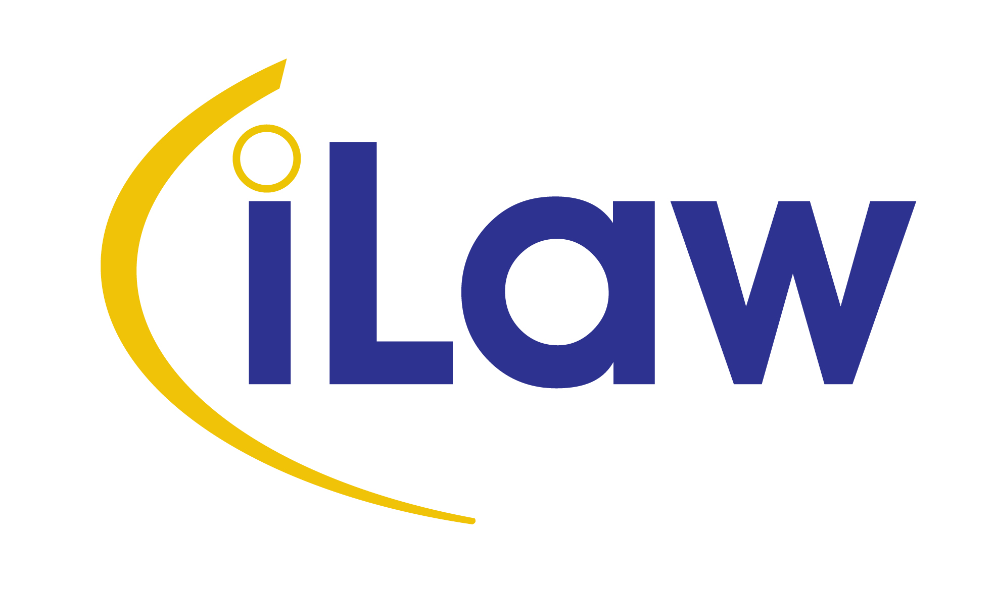

EJTN - Seminar on Maintenance Obligations in Europe

Centro de Estudos Judiciários (CEJ) – Largo do Limoeiro,
Lisbon - Portugal

18th - 19th October 2012

Day 1: Thursday 18 October 2012

9.00 Arrival and registration of participants

9:30 Opening of the seminar
EJTN Representative and Authority of the host country (Centro de Estudos Judiciários)

10.00 Council Regulation 4/2009 of 18 December 2008 on jurisdiction, applicable law, recognition and enforcement of decisions and cooperation in matters relating to maintenance obligations – an overview; Ms. Alegría Borrás

11:00 Coffee break

11:20 Applicable law in matters relating to maintenance obligations – The 2007 Hague Protocol; Mr. Andrea Bonomi (Tbc)

12:30 Open questions and debate

13:00 Lunch (organised by the host country)

14:00 Regulation 4/2009 – Recognition and enforcement of decisions and cooperation between central authorities; Ms. Florbela Lança

15:00 Coffee break

15:20 Open questions and debate

16:30 End of the first day

Day 2: Friday 19 October 2012

9:00 Regulation 4/2009 and rules of jurisdiction; Mr. Ian Curry-Sumner
10.00 Recovery and maintenance claims – Challenges and best practices
Workshops: participants will be divided into 2 EN groups and 1 EN/FR group
11:30 Coffee Break
11:50 Recovery and maintenance claims – Challenges and best practices
Workshops: (cont.)
12:50 Reports on the results of the workshops
13:15 End of the seminar by EJTN Representative

